Experiment-08
Question: 1
WAP in python to count frequency of characters in a file.
Code:
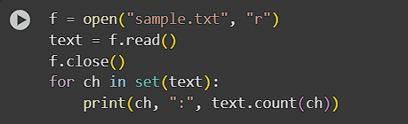
Output:
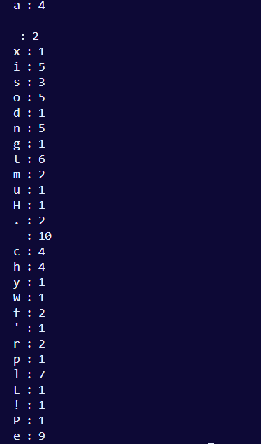
Question: 2
WAP in python to print each line of a file in reverse order.
Code:
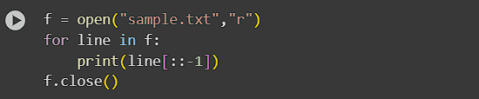
Output:
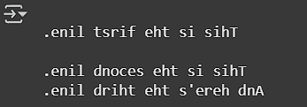

Question: 3
WAP in python to count the number of characters, words and lines in a file.
Code:
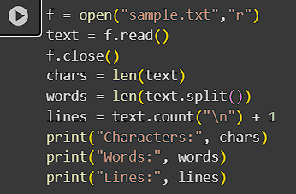
Output:
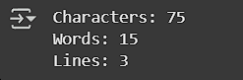
Question: 4
WAP in python to read an entire text file.
Code:
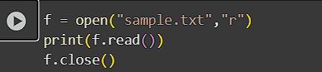
Output:


Submitted by:
Name= Abhinav Sharma
Reg no.= 2401020441
Branch= AI & DS
Group=4

